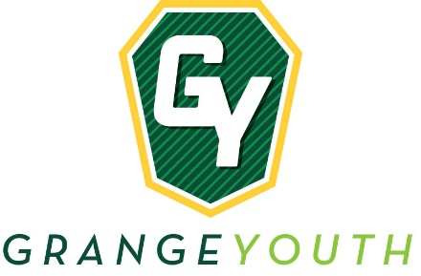

YOUTH OFFICER TEAM SPONSOR VEST

NEW OPPORUNITY! Become a sponsor for a member of the Youth Officer Team. Beginning with the Youth Officer Team selected for the Pennsylvania State Grange Session in October 2021, the Youth Officers will be presented with an official Youth Team vest, including the Grange logo and their name embroidered on the front. It’s time for our State Youth Team to have a distinct identifier, similar to those of the FFA and 4-H. The Young and Young Adults Committee has selected black vests for the Youth Team and gray vest for sponsors.

To sponsor a member of the Youth Team and receive your own gray vest, we are requesting a donation of at least $100.00 to the PA Grange Youth Department. Donations can be made by Granges, individuals or small groups but only 1 supporter vest per $100.00 will be available. To sponsor a member of the Youth Team without a supporter vest, we are requesting a donation of at least $60.00. If you have a specific office that you would like to sponsor, please annotate that on the form below.

Sponsor Name:

Address:

Phone: |  | Email:

I/We would like to sponsor |  | office

Select one:

$100 donation to sponsor a member of the Youth Team and receive a supporter
vest, size:

$60 donation to sponsor a member of the Youth Team

Please send this form and sponsorship to: Jennifer Danko, 22 Twins Avenue, Newport PA 17074

The Youth Team will be wearing the vest while participating in any Grange activity to show their pride in this great organization. Thank you for your help in recognizing our amazing Youth and Young Adults!

